Speaker: Cyrus Moore, Local History Corps Rep
Southeast Ohio History Center
Athens, Ohio
Outline: Introduction to Collection Management Policy
Discover what every policy should have
Explore ways to improve existing policies
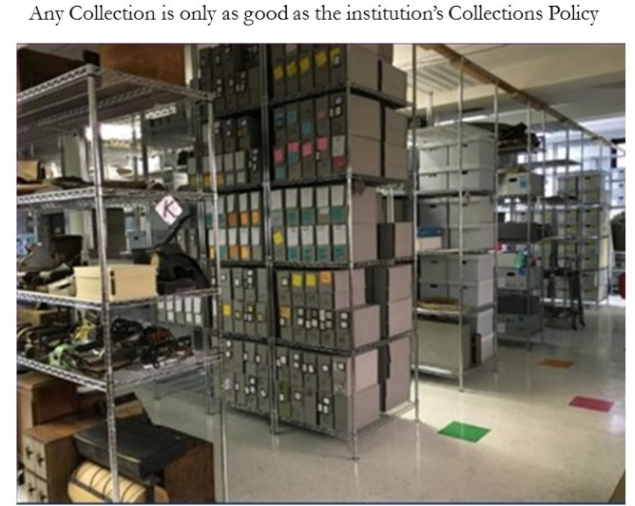
A written collection management policy is essential to acquire, maintain, and dispose of donated items.

This month’s discussion provides a top-level overview of many Collection Management Policy topics. Later meetings will go into more detail on many of these topics.
The slides were provided, so I removed their background and pasted them in with commentary where additional useful information was discussed.
Also provided were a guide from the American Alliance of Museums on Developing a CMP as well as PDF files of 2 sample Collections Managements Policies, One (5 page) from Delaware, one (26 page) from Central Florida. These will be on the NHS cloud storage site.

Future Workshops: Workshop # 2: June 23. Collection Documentation
Workshop #3: July 14. Cataloging, Data Entry
Workshop #4: Aug. 11. Storage & Preservation
Include information on what we do accept and what we do not. For example, in our case, we defer anything relating to Wm. McKinley to the McKinley Memorial Museum.

Collection Policy should be reviewed roughly every 5 years.
Do NOT let donor dictate the terms of use. The policy should state the we have the right to display, preserve, etc. as we determine best for the NHS mission.
Do not reinvent the wheel. Look at other institution policies and use them to fashion ours.
Examples of other collection policies were provided with these slides. They are attached at the end.

The environment in the house is an important factor in procedures required to properly maintain the collection

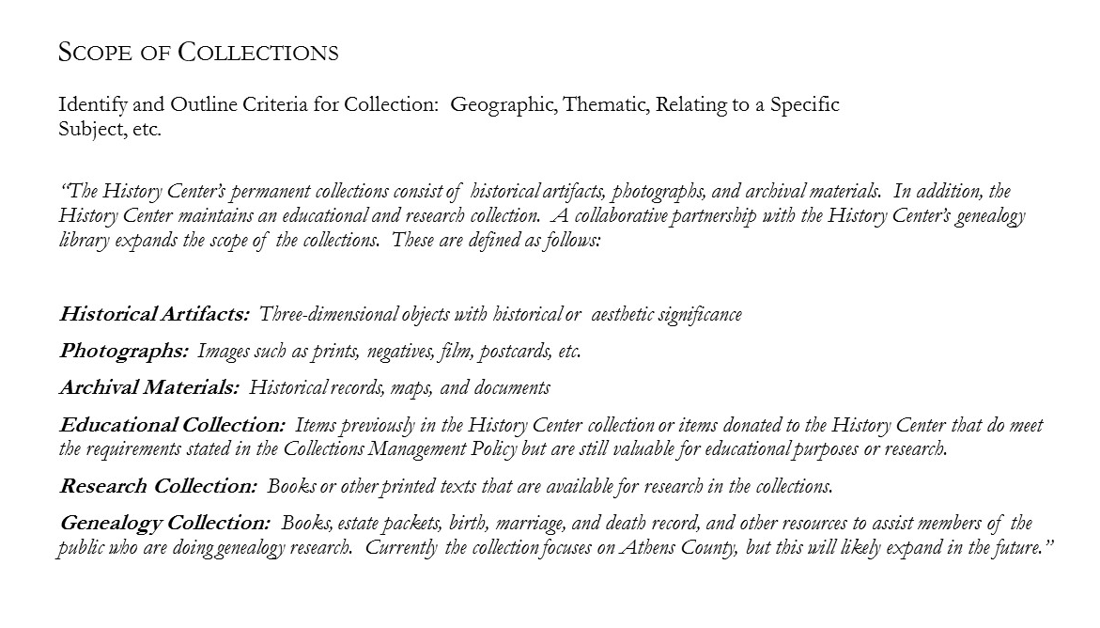
This provides examples of the types of things that may be included in a collection. Our collection does include all these. However, we do not have a separate “Educational Collection” that can be taken from the building for use in off site presentations such as trips to schools.

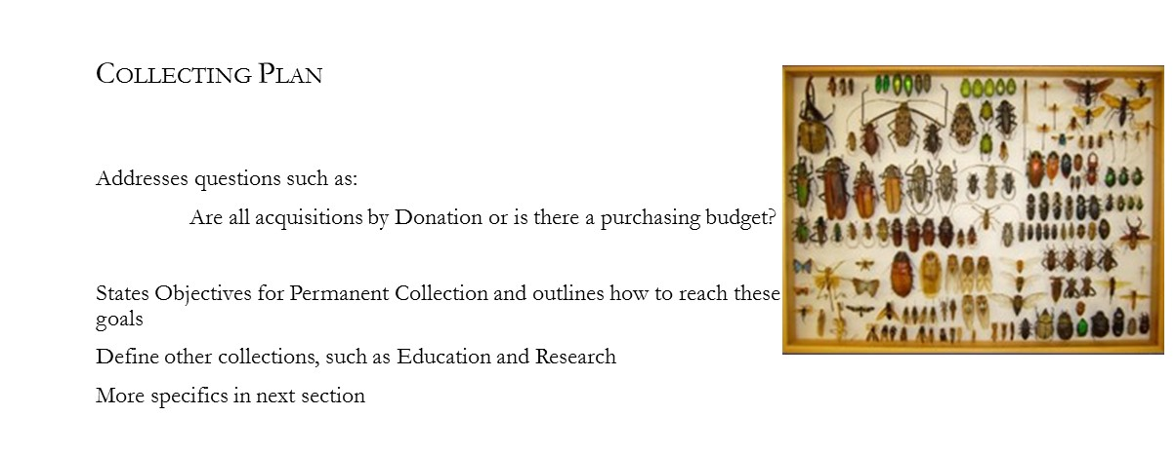

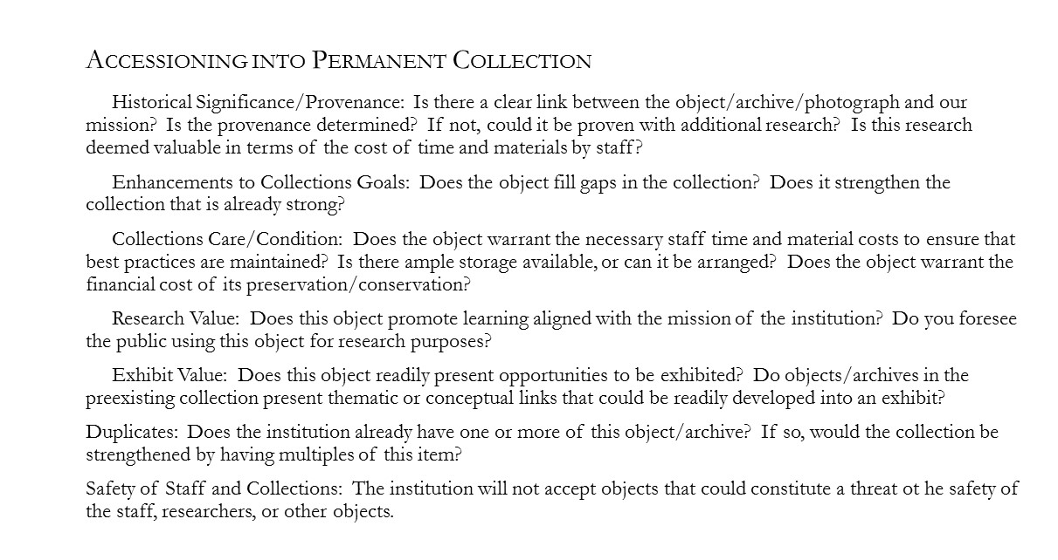
Duplicates: If we already have an item, is the offered item in better condition. In other words, should we accept the new item and get rid of the similar item we already have?
Would multiple copies be a good idea. Might one be defined as part of the educational collection that may leave the building.
Safety: An example given was a museum that accepted an old doctor’s bag. Later, when they looked closely at it they found some old medicine that had deteriorated and might have been dangerous if anyone opened the vials.

Accepting an item involves considerations of the cost and the manpower required to maintain the item in acceptable conditions.
It is essential to write down any information that the donor can provide.
Do not accept something if we cannot get rid of it or if it has unacceptable requirements such as that it must always be on display.
It is important to have a statement on the web site and in the collection management policy that effectively says:
- Do NOT drop objects for donation off outside the WT house.
- After 90 days, any item dropped off with no donor information becomes the property of the Niles Historical Society.
- After 90 days, we will decide what to do with the item including accepting it into our collection, offering it to another institution we decide is more appropriate, or put it in the trash. (We are required by law to hold things dropped off for 90 days; then we can do what we want with them)

Examples of criteria:
- Has the condition deteriorated to the point that it is no longer useful as a display item or for research?
- Is it still needed?
- Has an alternate been donated that is in better condition or is more directly applicable to the museum mission?
Disposition: How do we dispose of unwanted items? What records are needed? Offer to another museum?
If we decide to sell an object, they recommend using an auction house, NOT ebay or equivalent.

Do we accept loans from other institutions for special, short term displays? If so, what are the conditions of the loan? All this should be defined in writing and the loaning institution must understand and accept our policy. We also need to understand and accept any of their policies before the loan is accepted.
Similar requirements are needed if we loan any part of our collections to another institution.
Loans can be a hassle, but the can also provide benefits.
Define the length of the loan. 6months with an option to renew for example.
Permanent loans are a VERY BAD IDEA. You are taking responsibility for the cost of maintaining the object, but do not own it.
Another BAD IDEA is accepting an item either on loan or as a permanent donation with conditions such as “the item must be on permanent display”. This may seem ok at the time of accession but make it difficult to modify displays.

Be prepared for items in an educational display to be damaged or lost.

An ethics statements may be in the by-laws or elsewhere.
Major concerns:
- People involved in the acquisition or deaccession process who have personal interests. An example given was someone who had a personal collection and was offering donors money to acquire items he wanted for his personal collection.
- Accepting a donation and then selling it can damage an institution’s reputation for integrity.
- If items are sold, the proceeds should go back into the collection – if otherwise, make it very clear at the time of donation.
If the building is damaged, where will we move the Collection? Perhaps it could be moved into a city building temporarily.
Is there a fund set aside for emergencies? NOTE: Generally, a campaign for recovery dollars happens after the fact; few institutions have a disaster fund.
Do we have offsite storage of data?

StEPs is a program developed by The American Association for State and Local History (AASLH). This next section is copied from their web site.

Information copied from the AASLH web site.

The American Association for State and Local History (AASLH), founded in 1940, is a national association that provides leadership and support for its members who preserve and interpret state and local history in order to make the past more meaningful to all people.

WHAT DOES AASLH DO?
- Advocacy: We work for increased funding and visibility for the field and represent the field on national committees and task forces.
- Leadership: We create and run high quality continuing education programs for individuals and organizations, including the first-ever national standards program for small and medium history organizations (StEPs).
- Community: We facilitate networking and discussion both in person at our Annual Meeting and on-site workshops as well as online through our website, Online Conference, and Affinity Groups.
- Resources: We offer programs, books and book series, Technical Leaflets, History News magazine, and our searchable online collection of over 1,000 other resources.

Membership
Institutional memberships give your entire staff access to the benefits of membership. In our easy-to-use member database, you can add and remove staff from your institutional account as needed. Institutions that are members get discounts on important resources like Past Perfect software, the AASLH book series, and continuing education events for organization leaders and support staff.

MEMBERSHIP DUES $118 Annually

RESOURCES
Research, books, Technical Leaflets, websites, podcasts, webinars, white papers, industry trends, articles, position papers, sample planning documents, and more.

STEPS:

STANDARDS & EXCELLENCE PROGRAM
StEPs is the Standards and Excellence Program for History Organizations. It helps small- and mid-sized history museums, historic sites and houses, including all-volunteer ones, assess policies and practices, manage daily operations and plan for the future.
StEPs is AASLH’s self-study program designed specifically for small- to mid-sized history organizations, including volunteer-run institutions. Through a workbook, online resources, and an online community, organizations enrolled in StEPS assess their policies and practices and benchmark themselves against national museum standards. The program is divided into six sections that can be addressed in any order. In each section, organizations can identify their current practice as Basic, Good, or Better. Each level has its indicators, allowing organizations to set realistic goals and tackle challenges in small, manageable steps. Work in each section at your own pace using checklists, worksheets, sample documents, and the 24/7 online community.
After completing each level within a section, your organization will receive a certificate from AASLH that lets your community and stakeholders see that you making meaningful progress toward national standards. And that translates into increased credibility that can help justify funding requests.

The StEPs Workbook
“I LOVE the StEPs program! I’ve been devouring the workbook – it’s very helpful.” -StEPs Member
The StEPs workbook is more than just a workbook. It’s a manual and a compass for progress. The workbook is organized into six sections that can be used in any order, according to your organization’s individual needs and priorities:
- Mission, Vision, & Governance
- Audience
- Interpretation
- Stewardship of Collections
- Stewardship of Historic Structures & Landscapes
- Management
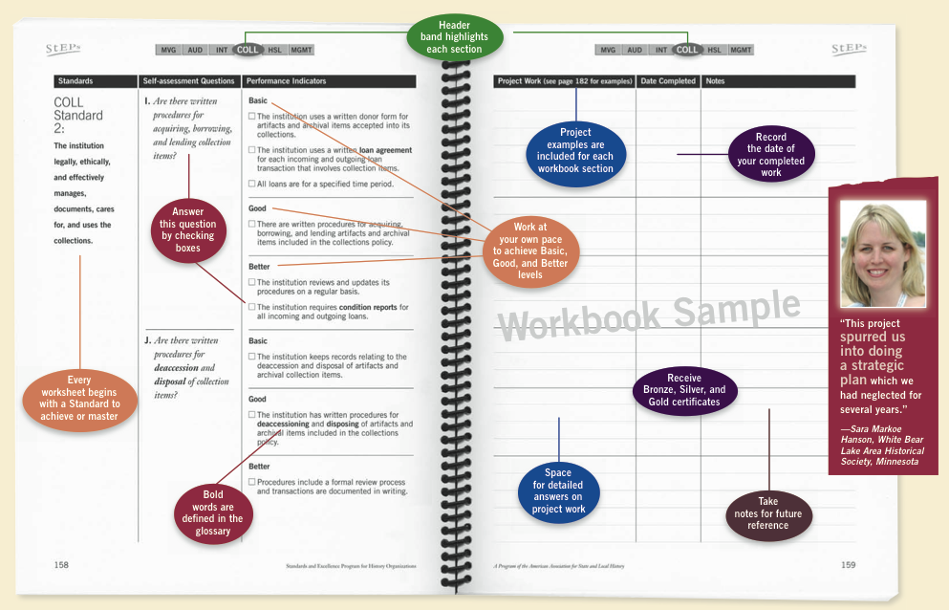
In each section, you will find discussion prompts, a list of standards, unacceptable practices, and overarching statements that describe an institution that meets standards. Then, for each standard, there are workbook pages that break the standard down into the Basic, Good, and Better levels with performance indicators, and workbook pages for planning projects needed to reach those indicators. At the end of every section are project suggestions, resource lists, and forms for certificate application. A full glossary defines terms used in the workbook.

StEPs Worksheet example provided on the AASLH web site.

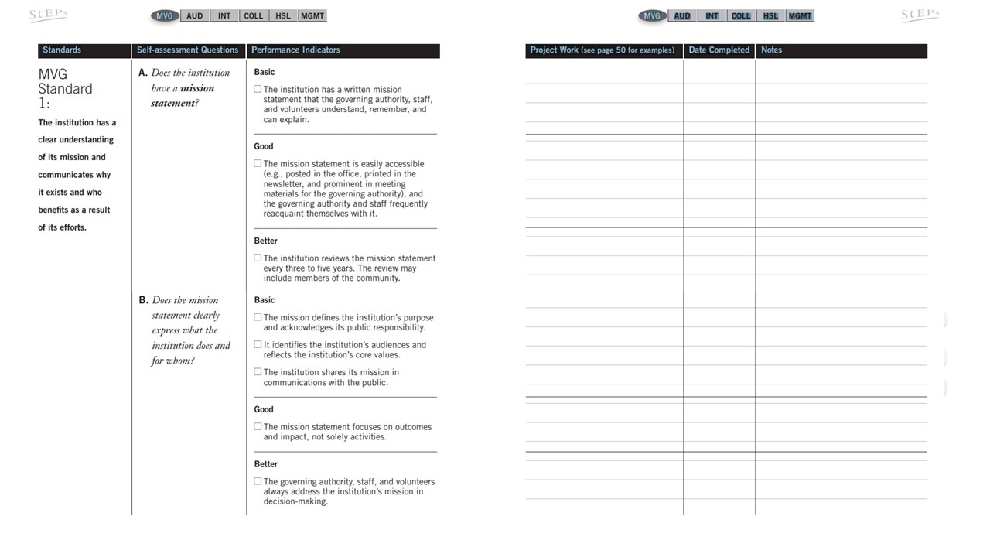
Next are expanded (readable) views of the left side of a couple of worksheet page examples.

